A Review of Implementation of Long Short‐Term Memory and Gated Recurrent Units on grouped time‐series data to predict stock prices accurately.
Lawi, A., Mesra, H. & Amir, S. Journal of Big Data 9, 89 (2022).
The research paper looked at previous usage of deep learning techniques and broadened upon them. The authors saw where the predictive models had performed poorly in prior studies and proposed 8 new techniques combining both LSTM and GRU and four neural network block architectures. The block architectures consisted of the Direct model, which was just the direct output from the LSTM/GRU model predicting the stock price. The downsizing model downsizes the output to 160 values that are then used for the prediction. The tuned downsizing model adds a hyperparameter to the last model by applying dropout to the 160 values. Finally, the stabilised downsizing model takes the 160 values, applies another LSTM/GRU to them and then uses that final output for prediction. These were then assessed using three accuracy measures derived from the loss function, Mean Absolute Percentage Error (MAPE), Root Mean Squared Percentage Error (RMSPE), and Rooted Mean Dimensional Percentage Error (RMDPE). They were chosen to represent the lower, true and higher accuracies in the model.
Essentially the paper is comparing the predictive capabilities between LSTM and GRU’s in their abilities to work with time-series data, which in this case would be the stock market. Time-series data consists of data that is collected sequentially across a period of time, usually at select intervals. The models were made to determine if there were any predictive trends, how they can be evaluated and how to minimise risk to therefore reduce loss. (Ingle V, Deshmukh S, 2021) Recurrent neural networks are deep learning prediction models that operate on time-series data, its processes are done repeatedly over time as more inputs are added sequentially, making them suitable for predicting stock price movements. (Goodfellow et al, 2016) RNNs work by repropagating the gradient through itself to find the optimal value but when the data it processes is too large the gradient may disappear or diverge as time becomes longer. This is because RNNs only have one activation function in their intermediate layer. LSTMs and GRUs are widely used development architectures which are variants of recurrent neural networks. (Le XH et al 2019) LSTMs and GRUs were designed to solve the vanishing gradient problem, due to magnitudes exploding or shrinking, they have multiple activation functions and consist of gates to regulate the flow of information in, within and out of the cell. GRUs were designed to be a simpler version of the LSTM. (Baytas IM et al 2017) LSTMs consist of three gates; input, forget and output, and GRUs only have two, the update and reset gates. This leads to different levels of complexity, while LSTM’s have higher complexity and higher computation cost, it functions better on long-term memory tasks compared to GRU’s which show similar levels of performance on shorter sequences.
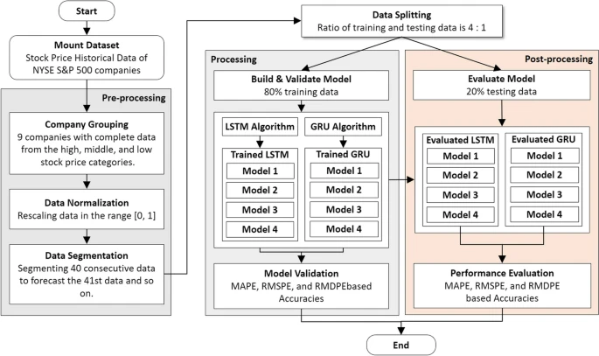
There were other studies which incorporated machine learning techniques for forecasting stock price trends that were referenced in this paper, such as using cumulative ARIMA combined with least squares support vector machine (ARIMA-LS-SVM) model (Xiao J et al, 2020), a machine learning method involving data for dimensionality reduction and KNNC for trend prediction (Khattak et al, 2019). There were also studies using deep transfer learning with related stock information (DTRSI) taking advantage of a deep neural network and transfer learning to combat the issue of having insufficient training samples (Liu Q et al, 2021). Other investigations have used LSTMs under different fixed conditions (Jin Z et al, 2019). However, these models that either used traditional machine learning methods, various hybrid training or deep learning were almost only trained by the stock data feature without external information or examining the interaction between upstream and downstream information. This study targeted those factors using appropriate methods while modelling the data.
Figure 1: Proposed LSTM and GRU forecasting method
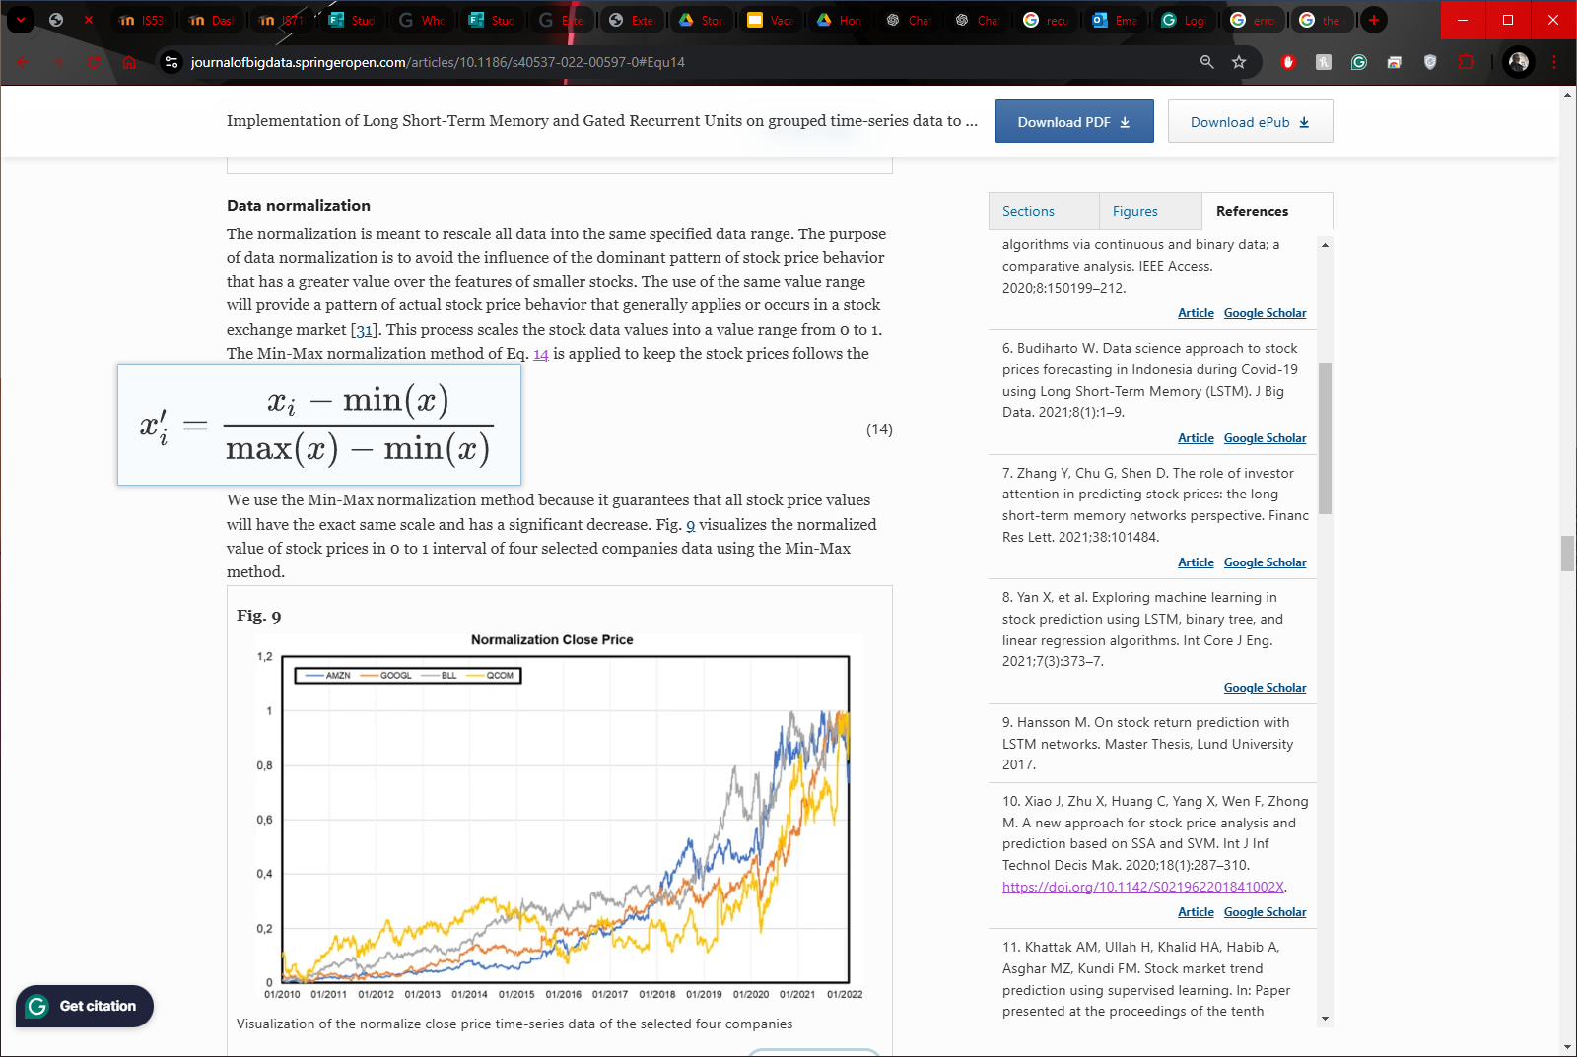
The authors used historical stock price data for four companies with complete time-series data that were grouped into two groups based on higher and lower stock prices: AMZN, GOOGL, in the higher bracket and BLL, QCOM in the lower bracket. The selection was made to represent the same technical price behaviour that occurs in the NasdaqGS stock market, which was acquired from the Yahoo! Finance website. The data was first normalised and, essentially, rescaled so all data would fit in a specific range regardless of how much GOOGL would outperform QCOM. The purpose of this is to avoid the influence of the more dominant patterns present between the different companies' stock prices. This ‘same value range’ will show the patterns and behaviour rather than the performance of the stock. This was done using the Min-Max normalisation method as it scales all the stock data values into a value range from 0 to 1 and has a significant decrease.
Figure 2: The Min-Max normalisation formula
The method proposed in this paper consists of three main stages: pre-processing or data preparation, data processing or model building, and finally, post-processing or performance evaluation. Step by step, firstly, both the LSTM and GRU work separately to learn the patterns in each company's stock price data to create their predictions. Next, the prediction model outputs are combined to make a flattened array, essentially a large list of all the companies’ behaviours, pooling their predictions. The list is sent through the ‘concatenation model’ to understand how all the companies may be influencing each other and gain an understanding of the overall movement pattern of the stock market from the chosen companies. The results from the concatenation model are then fed back into the proposed LSTM and GRU models; this refines the predictions on what each stock will do next. The idea is that by combining the two, the paper hopes to make better predictions about the stock prices of each company.
The data was segmented, separating, and then grouping, the data was grouped, turning it from raw data into grouped data with a predicted value. This was done to account for stock market holidays and weekends, ensuring that gaps in the time-series data did not negatively impact model training and evaluation​. Also by grouping data from multiple companies, the models could incorporate interdependencies and interactions between related stocks. This segmentation aimed to capture upstream and downstream influences across companies, which are often overlooked in traditional stock prediction methods. Also, segmenting the data allowed for a more structured approach to the preprocessing stage, making it easier to see if the segmented sections were consistent and optimised for the LSTM and GRU architectures.
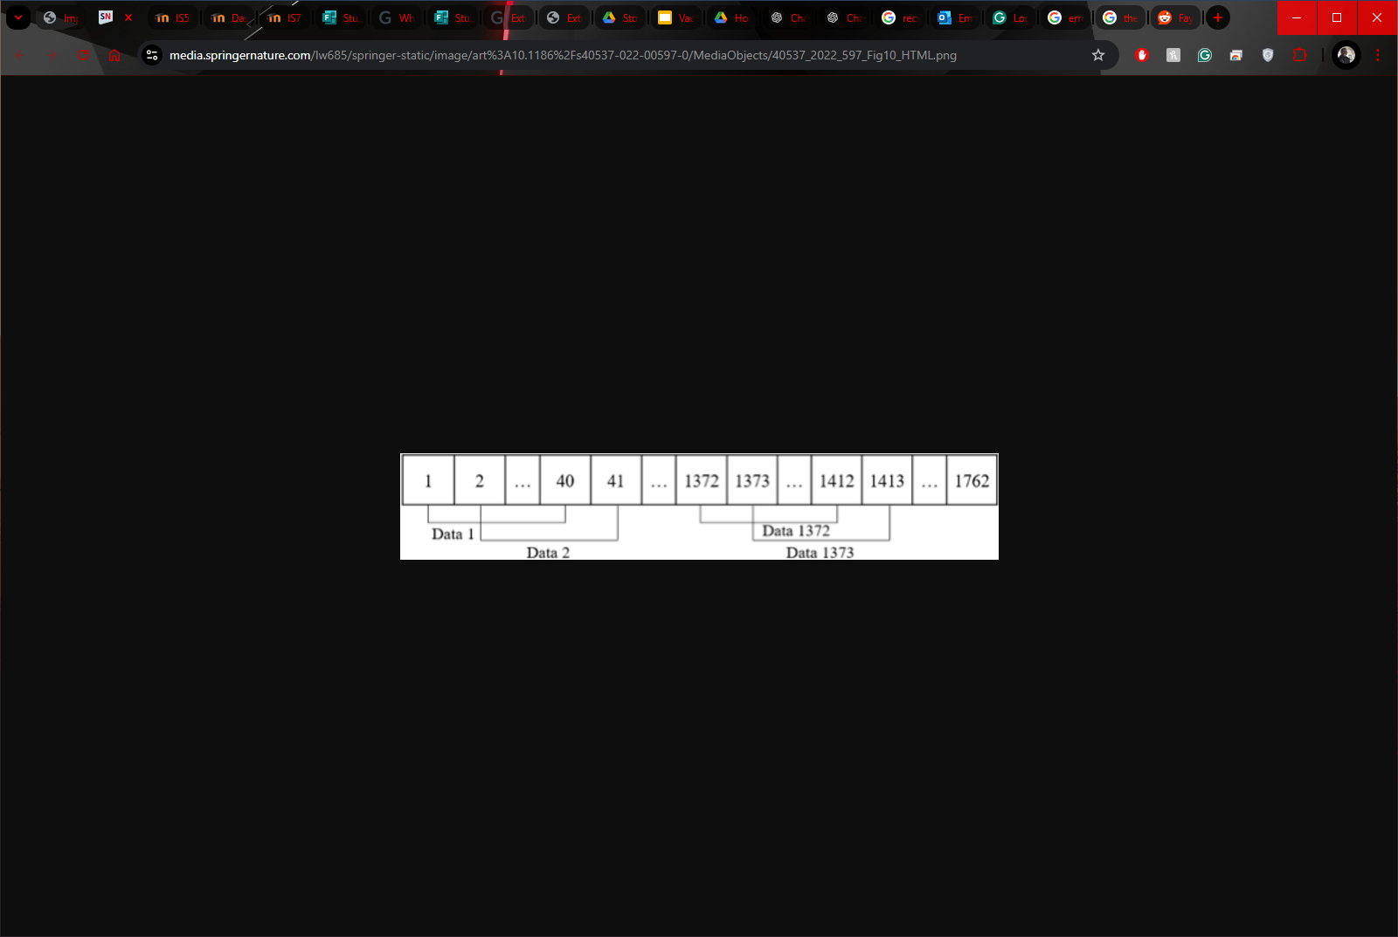
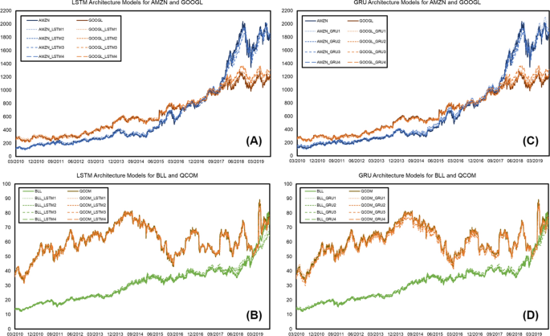
The segments take the first 40 consecutive timestep data, labelled x, and use that to predict the next 41st data. This is then iterated throughout, i.e. 2nd data to the 41st is used to predict the 42nd until it reaches the last timestep data. Each segment of 40 consecutive data equates to two months of data, which is ideal for forecasting. Variations of 20 (1 month) and 60 (2 months) were interesting topics of proposed further study. The segmented data of 3004 data chunks were divided 80/20 for training and testing, 2,403 train and 601 test, training being the first 9 years 9 months from 2010-03-03 to 2019-09-17, and the testing consisting of the last two and a half years from 2019-09-18 to 2022-02-03.
Figure 3: Illustration of the data segmentation
Figure 4:Trained LSTM and GRU architectural models of four companies
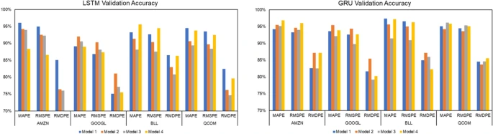
The results of the data segmentation in the training dataset, 2403, were validated using the LSTM and GRU trained models. Figure 4 shows the performance of the 4 architectural models compared to the actual stock price of AMZN, GOOGL, BLL, and QCOM and both the LSTM and GRU performance. This is ideal as it makes it simple to evaluate the variance between the predicted models and the actual stock, and the performance difference between LSTM and GRU on stock forecasting. The performance of the trained models were visualised in Figure 5, showing each architectural model's accuracy for each of the four companies, using the three performance accuracy measurements previously stated, MAPE, RMSPE, and RMDPE, for the higher, true and lower accuracies, and two tables, for both LSTM and GRU. Overall in terms of true accuracy for the LSTM model, the first model tended to consistently predict stock prices at roughly 95% to 97% for AMZN, BLL and QCOM. GOOGL had a slightly lower accuracy with its strongest performing model roughly performing at 90%. At a glance, it is easy to see that the GRU models had more consistency in predicting stock prices throughout the four companies compared to the LSTM models. The paper states that all models had good accuracies in the range of 92.74% to 98.47% for MAPE, 90.44% to 97.96% for RMSPE, and 66.64% to 90.73% for RMSDE. However, the LSTM models outperformed the GRU models in predicting AMZN stock price using higher accuracy evaluations. QCOM showed good performance using MAPE but is not significantly different to the RMSPE and RMDPE models
Figure 5: Visualization graph of LSTM and GRU Trained Accuracy
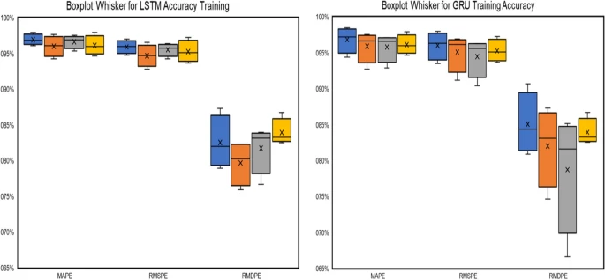
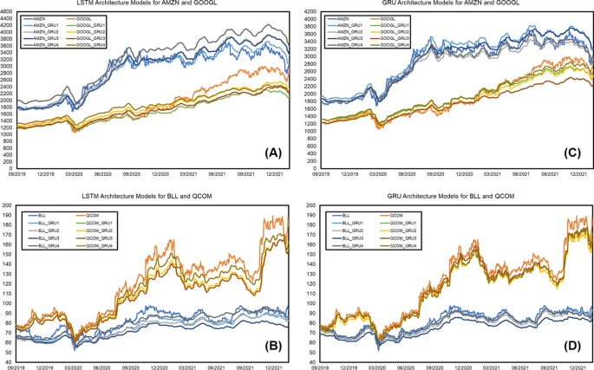
After the models were completely trained on the dataset containing 2403 consecutive data, they were then introduced to the unseen test dataset 601 to make predictions in the validation stage. This was used to evaluate the forecasting performance of the four models for LSTM and GRU, respectively. The eight models were then implemented using python and can be found on the Github repository in the references. Figure 6 depicts the stock trends for the four companies in the last two and a half years of the data, making 601 data. The four architectures are modelled alongside it, which is ideal for comparison. Overall all the trained models show good accuracy in predicting the test data.
Figure 7:Boxplot Whisker for LSTM and GRU trained model
Figure 6: Validation LSTM and GRU architectural models of four companies
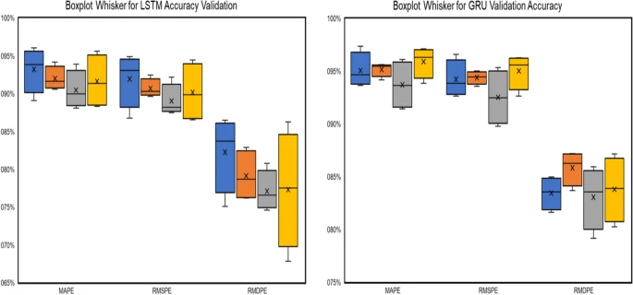
The results for training data displayed that the first GRU Model provides the highest accuracy for the three metrics with 98.48% (MAPE), 97.98% (RMSPE), and 90.73% (RMDPE). Whereas the validation results of the testing data, the first GRU Model had the highest accuracy 97.37% (MAPE) and 96.60% (RMSPE), and GRU Model-2 yielded 87.19% for RMDPE. The Boxplot-Whisker results, however, showed that LSTM models always produce smaller accuracy deviations than GRU models. Figure 7 shows the Boxplot whisker for the training of the LSTM and GRU models, while Figure 8, shows the validation models. From the whisker plots, it can be determined that the LSTM models are more consistent or convergent in their accuracy values.
Figure 8:Boxplot Whisker for LSTM and GRU validation model
After some in-depth research into the paper and the other articles referenced, many positives were highlighted to me, though not without some questions and concerns. Firstly, I appreciated how the article used multiple evaluation methods and that it was assessed using a confidence range when providing the performance of the models. Incorporating the lower, true and higher accuracies improves the reliability of the work that was done, as the model won't consistently have an accuracy of 97% when predicting new AMZN stock data, for example. Through this addition, it allows any slight variance in the result, if it were to be trained on new data, to be explained. I appreciate that the proposed method consisted of 4 new model architectures designed specifically for the data as they change the output shape, but they each stay relative to each other, and it specifically works well with time-series data. I thought that one of the models, the tuned downsizing model, was a great addition because adding hyperparameters allows the model to be tuned in the future, this Is beneficial for further implementations of the model and can improve fit or allow for other insights into the data. The use of the Min-Max formula was good, and the range that the data was scaled down to, 0 to 1, Is ideal for different types of companies: high-performing, average, and low-performing. Regardless of which group the company may belong to, the will be equal significance in the decrease of all of them, though other bands of stocks such as penny stocks or cryptos wouldn’t suit as their volatilities are either too sporadic or steady, which would not scale to make accurate predictions. Also, the amount of research that went into the paper shows good insight; a lot of other articles show advancement in this type of research, specifically in deep learning, time-series forecasting and stock market prediction. There was some critique of what previous studies had been unsuccessful with and looked for ways to improve upon those shortcomings and for new topics of interest to pursue. This study provides the code for the implementation of the eight models created which aids in reproducibility and shows transparency in the methods taken.
Some concerns I had were that it seems that the reasons MAPE, RMPSE, and RMDPE were chosen were based solely on the idea that they performed well in analysing time-series data and had been used previously by many other studies from 2016 to date (He T, Droppo J, 2016). There doesn’t look to be any insight into how or why they perform well with this kind of data, just blind belief in previous studies. The paper doesn’t speak on how to mitigate the issue of the models overfitting, which is a common occurrence with deep learning models like LSTM and GRU. There is a model that uses dropout techniques that intends to train a model with different parameters from the others though. There wasn't any mention of the ethics of the paper or how a model such as this, while tested on accuracy models, still wouldn’t assure of success trading in the stock market or any explicit mention of compliance with Yahoo! Finance and its data source usage restrictions if there were any. Also, how advanced predictive tools such as this may benefit individuals or businesses disproportionately to those without access to high-end computational resources. There is no mention of the scalability of the models or the computational costs of running them, as they are deep learning frameworks running them may require a large amount of computational costs. This can massively affect reproducibility. Adding more hyperparameters would be majorly beneficial to the models' performance being able to affect the learning rate or batch size can change how the well the model fits the data, possibly reducing computing time by increasing convergence and reducing computation cost. It can also help to prevent overfitting and increase stability by adjusting momentum parameters.

References A Review of Implementation of Long Short‐Term Memory and Gated Recurrent Units on grouped time‐series data to predict stock prices accurately. Lawi, A., Mesra, H. & Amir, S. Journal of Big Data 9, 89 (2022). https://doi.org/10.1186/s40537-022-00597-0 (all figures were taken from this article)
Ingle V, Deshmukh S. Ensemble deep learning framework for stock market data prediction (EDLF-DP). In: Paper presented at the Global Transitions Proceedings vol 2.1. 2021; p. 47–66.
Goodfellow I, Bengio Y, Courville A. Deep learning. Boston: MIT Press; 2016.
Le XH, et al. Application of long short-term memory (LSTM) neural network for flood forecasting. Water. 2019;11(7):1387.
Baytas IM, et al. Patient subtyping via time-aware LSTM networks.’In: proceedings of the 23rd ACM SIGKDD international conference on knowledge discovery and data mining 2017.
Xiao J, Zhu X, Huang C, Yang X, Wen F, Zhong M. A new approach for stock price analysis and prediction based on SSA and SVM. Int J Inf Technol Decis Mak. 2020;18(1):287–310. https://doi.org/10.1142/S021962201841002X.
Khattak AM, Ullah H, Khalid HA, Habib A, Asghar MZ, Kundi FM. Stock market trend prediction using supervised learning. In: Paper presented at the proceedings of the tenth international symposium on information and communication technology 2019. 2019. p. 85-91. https://doi.org/10.1145/3368926.3369680
Liu Q, Tao Z, Tse Y, Wang C. Stock market prediction with deep learning: the case of China. Financ Res Lett. 2021. https://doi.org/10.1016/j.frl.2021.102209.
Jin Z, Yang Y, Liu Y. Stock closing price prediction based on sentiment analysis and LSTM. Neural Comput Appl. 2019. https://doi.org/10.1007/s00521-019-04504-2.
https://github.com/armin-lawi/ForcastingStockPrice-with-Grouped-Dataset.
He, T.; Droppo, J. Exploiting LSTM structure in deep neural networks for speech recognition. In Proceedings of the 2016 IEEE International Conference on Acoustics, Speech and Signal Processing (ICASSP), Shanghai, China, 20–25 March 2016; pp. 5445–5449

